For Each Loop
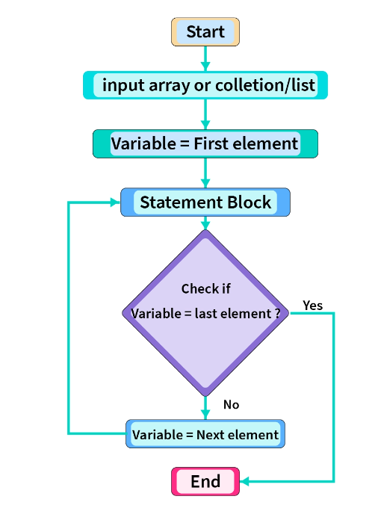

🔁 FOR-EACH LOOP (Enhanced for Loop) – COMPLETE NOTES

1️⃣ What is a for-each loop?
A for-each loop is a special loop in Java used to iterate (traverse) elements sequentially from:
- Arrays
- Collections (List, Set, etc.)
👉 It automatically moves from first element to last element
👉 Programmer does not control index or counter

2️⃣ Why was for-each loop introduced?
Before Java 5:
- Only normal for loop existed
- Code was lengthy and error-prone (index mistakes)
Java introduced for-each loop to:
- Reduce boilerplate code
- Improve readability
- Prevent index-related bugs

3️⃣ Syntax (Very Important)

▶ For Array
for (datatype variable : arrayName) {
// logic
}

▶ For Collection
for (datatype variable : collectionName) {
// logic
}

4️⃣ Meaning of Each Part (Line by Line)
for (int x : arr)
- int → datatype of element
- x → local variable (temporary copy)
- : → read as “from”
- arr → array or collection
📌 Meaning:
For every element x from arr, execute the loop body.

5️⃣ Internal Working of for-each Loop

🔹 For Arrays
✔️ Internally, for-each uses a normal for loop
✔️ It uses:
- a hidden index
- from 0 to length - 1
📌 You don’t see the for loop, but it exists internally.

🔹 For Collections
✔️ Internally, for-each uses an Iterator
✔️ It repeatedly calls:
- hasNext()
- next()
📌 You don’t see the iterator, but it controls the traversal.

🧠 Why this understanding is important
Because it explains:
- why index is not available
- why modification fails
- why ConcurrentModificationException happens
- why for-each is read-only

🏆 Interview-Perfect One-Line Answer
Yes, internally the for-each loop is translated into an index-based for loop for arrays and an Iterator-based loop using hasNext() and next() for collections, with these details intentionally hidden from the programmer.

6️⃣ Flow of Execution (Step-by-Step)
- Control enters loop
- First element is copied into loop variable
- Loop body executes
- JVM automatically moves to next element
- Continues till last element
- Loop exits automatically
📌 No condition
📌 No increment
📌 No index handling by programmer

7️⃣ Key Characteristics (Must Remember)

✔ Sequential Access Only
- Always starts from first element
- Always ends at last element

✔ Forward Direction Only
- Cannot traverse backward
- Cannot skip elements

8️⃣ No Index Access ❌ (Critical Limitation)
In for-each loop:
- Index does NOT exist
- Position cannot be determined
❌ Invalid:
arr[i]
✔️ If index required → use normal for loop

9️⃣ Read-Only Nature (Most Important Concept)
For-each loop provides read-only access.
Example:
int[] arr = {10, 20, 30};

for (int x : arr) {
x = x + 5;
}
❓ Does array change?
👉 ❌ NO
📌 Reason:
- x is a copy of array element
- Original array remains unchanged

🔍 Interview Line
For-each loop variable holds a copy of element, not the actual element.

10.

🔹 Core Concept 1

Method calls are NOT the restriction
for-each loop does not ban method usage.
You are free to call any method inside the loop.
What matters is what the method does, not where it is called.
✔️ If a method only reads data → safe
❌ If a method changes structure → unsafe

Example
for (String s : list) {
System.out.println(list.size()); // ✅ allowed (read-only)
}
📌 Method calls themselves never cause errors.

🔹 Core Concept 2

Structural modification is forbidden
for-each loop internally relies on:
- a hidden index (arrays)
- a hidden iterator (collections)
These mechanisms expect the container to stay unchanged during traversal.
Changing:
- size
- order
- structure
breaks this expectation and leads to runtime failure.

Example
for (String s : list) {
list.remove(s); // ❌ ConcurrentModificationException
}
📌 This is a design safety rule, not a limitation.

Structural Modification – What Exactly Is NOT Allowed in for-each

🔑 First, the Golden Rule (Lock This)
Any operation that changes the structure or traversal order of the collection during a for-each loop is NOT allowed.
The reason:
- for-each uses a hidden Iterator
- Iterator expects the collection to remain structurally stable

❌ Operations that are NOT Allowed (Cause Runtime Error)

1️⃣ Adding elements
list.add("A");
list.add(0, "B");
📌 Changes size → ❌

2️⃣ Removing elements
list.remove("A");
list.remove(0);
list.clear();
📌 Changes size → ❌

3️⃣ Sorting the collection
Collections.sort(list);
list.sort(comparator);
📌 Even if size stays same, order changes
📌 Iterator’s traversal order becomes invalid
❌ Not allowed during for-each
✔️ Sorting must be done before or after iteration

4️⃣ Shuffling / Reordering
Collections.shuffle(list);
Collections.reverse(list);
📌 Traversal order changes → ❌

5️⃣ Replacing entire collection
list = new ArrayList<>();
📌 Loop iterator still refers to old collection
❌ Logical error / unsafe

6️⃣ Bulk structural operations
list.addAll(otherList);
list.removeAll(otherList);
list.retainAll(otherList);
📌 Structure and size change → ❌

⚠️ Important Note (Interview Trap)
Even if:
- method is called using original reference
- or from another method
❌ Still NOT allowed if it modifies structure.
The iterator does not care who modified it.

✅ Operations that ARE Allowed (Safe)

✔ Read-only methods
list.size();
list.contains("A");
list.isEmpty();

1️⃣ set(index, value) – Allowed but not preferred
Core idea
- Replaces one element with another
- List size does not change
- Element position does not change
Snippet
for (String s : list) {
list.set(0, "X"); // ⚠️ allowed, but confusing
}
Conclusion
- Technically allowed
- Logically discouraged inside for-each

2️⃣ Object state change – Allowed and safe
Core idea
- Object state = data inside the object
- Collection shape remains unchanged
Snippet
for (Student s : students) {
s.setMarks(90); // ✅ safe and reflected
}
Conclusion
- Safe
- Intended usage of for-each

3️⃣ Primitive values – Change not reflected
Core idea
- Loop variable gets a copy
- Original array value remains same
Snippet
for (int x : arr) {
x = x + 10; // ❌ not reflected in array
}
Conclusion
- You modify the copy, not the stored value

🧠 MEMORY RULE (Lock This)
Change collection size ❌
Change collection order ❌
Change object data ✅
Change loop variable ❌

🏆 INTERVIEW ONE-LINER
In a for-each loop, the collection itself must not be changed, but modifying the data inside the objects stored in the collection is allowed.

🔒 FINAL LINE
for-each is for reading the collection, not reshaping it.

✔ Is set() allowed inside for-each?
👉 YES, it is allowed if:
- the method does not change
  - collection size
  - collection order
  - collection structure
set(index, value) only replaces an element, so:
- size stays same
- positions stay same
That’s why Java allows it.

⚠️ Why is it NOT encouraged?
Because:
- for-each is meant for reading
- set() is an update operation
- mixing read + update inside for-each hurts readability
- logic becomes confusing in real projects
📌 This is a design and clarity issue, not a technical error.

🔴 Important Clarification (Very Important)
This rule applies to collections (like List) that have set().
❌ Arrays do NOT have set() method
Arrays use index assignment:
arr[0] = 10; // array update
This should NOT be done inside for-each because:
- you don’t have index access
- for-each is not designed for updates

🧠 Final Memory Rule (Perfect)
If a method changes data without changing structure, Java allows it.
But for-each is still meant for reading, so updates are discouraged.

🏆 Interview-Perfect Line
Yes, methods like set() that replace elements without changing the size or order of a collection are technically allowed inside a for-each loop, but they are discouraged because for-each is designed for read-only traversal.

1️⃣1️ Structural Modification Problem (Fail-Fast)

Core idea
- In collections, a for-each loop internally uses an Iterator
- The iterator expects the collection not to change while it is being read

What happens if we change the collection?
If you:
- add elements
- remove elements
- reorder elements
while for-each is running, the iterator detects it.
👉 Java immediately throws:
ConcurrentModificationException

This mechanism is called fail fast

🔴 What is Fail-Fast in Java? (Very Clear Explanation)

🔹 Simple meaning first
Fail-fast means:
If something unsafe happens, Java stops the program immediately.
Java does not try to continue in a risky situation.

🔹 Why does Java need fail-fast?
When Java is iterating (looping) over a collection:
- Java expects the collection to stay unchanged
- Java follows a fixed path to move from one element to the next
If the collection suddenly changes:
- Java can lose track of where it is
- Java may skip elements
- Java may read wrong data
This leads to unpredictable results, which are dangerous.

🔹 What Java chooses to do
Java has two options:

❌ Option 1: Continue silently
- Might skip elements
- Might process some elements twice
- Might give wrong output
- Bugs become hard to detect

✅ Option 2: Stop immediately (Fail-Fast)
- Detect the unsafe change
- Throw an exception
- Force the developer to fix the issue
👉 Java chooses Option 2.

🔹 How Java detects a change (Core Internal Logic)

Step 1️⃣ Collection maintains a counter
Every collection (like ArrayList) keeps an internal number called:
👉 modification count
This count increases when:
- element is added
- element is removed
- structure/order changes
Example:
modCount = 0 // initial
add element → modCount = 1
remove element → modCount = 2

Step 2️⃣ Iterator takes a snapshot of that count
When for-each starts:
- Java creates an Iterator
- Iterator stores the current value of modCount as:
👉 expected modification count
So now:
collection.modCount = 2
iterator.expectedModCount = 2

Step 3️⃣ Iterator checks before every move
Every time Java tries to go to the next element:
- Iterator compares:
collection.modCount vs iterator.expectedModCount

Step 4️⃣ What happens if they match? ✅
If both are equal:
2 == 2
✔ Safe
✔ Continue iteration

Step 5️⃣ What happens if they don’t match? ❌
If someone modifies the collection during iteration:
collection.modCount = 3
iterator.expectedModCount = 2
Now:
3 != 2
👉 Java immediately throws:
ConcurrentModificationException
📌 Java stops the loop instantly.

12.

🔹 Why collections must implement Iterable ✔️
Collections like:
- ArrayList
- HashSet
implement Iterable.

What does Iterable mean (in simple words)?
“I know how to give my elements one by one.”
Because of this, Java can:
- ask the collection for an Iterator
- move step by step using:
  - hasNext()
  - next()
That is why this works:
for (String s : list) {
System.out.println(s);
}
📌 Java does not guess.
📌 Java follows the iterator’s step-by-step path.

🔹 Why plain Map does NOT work ❌
A Map is not a single sequence of elements.
It stores:
- keys
- values
- key–value pairs
So Java cannot decide:
- iterate keys?
- iterate values?
- iterate pairs?
That is why this is invalid:
for (Map m : map) { // ❌ not allowed
}
📌 Java has no single “next element” rule for a Map.

🔹 How Java wants you to be explicit ✔️

🔹 Map itself
- Map does NOT implement Iterable
- So for-each cannot be used directly on a Map
❌ Not allowed:
for (Map m : map) {
}

🔹 What Map provides instead ✔️
Map gives views of its data using these methods:

✔️ keySet()
Set<K> keys = map.keySet();
- Returns Set<K>
- Set implements Iterable
- So for-each works

✔️ values()
Collection<V> values = map.values();
- Returns Collection<V>
- Collection implements Iterable
- So for-each works

✔️ entrySet()
Set<Map.Entry<K, V>> entries = map.entrySet();
- Returns Set<Map.Entry<K, V>>
- Set implements Iterable
- So for-each works
- ✅ Most commonly used (key + value together)

🧠 Simple Memory Rule (Perfect)
Map ❌ → not Iterable
keySet() ✅ → Iterable
values() ✅ → Iterable
entrySet() ✅ → Iterable

🏆 Interview-Perfect One-Liner
A Map does not implement Iterable directly, but its keySet(), values(), and entrySet() methods return collections that implement Iterable, which is why for-each works on them.

🔹 Internal picture (Easy to remember)
Array → index exists → for-each works
Iterable → iterator exists → for-each works
Map directly → no single path → for-each fails

✅ Your statement — refined and corrected
✔️ To use for-each on a collection, it must implement Iterable.
✔️ Arrays do NOT implement Iterable, but for-each still works on arrays because Java knows their start and end in advance.
So yes — for-each works for both, but for different reasons.

🔹 Why for-each works for collections
- Collections are dynamic
- Size may change
- No fixed index rule
So Java requires:
- Iterable → gives Iterator
- Iterator → gives hasNext() and next()
📌 That is why collection must implement Iterable.

🔹 Why for-each works for arrays (even though they don’t implement Iterable)
Arrays:
- have fixed size
- have fixed order
- have known start (0)
- have known end (length - 1)
So Java can:
- use a hidden index
- move sequentially
- stop at a known end
📌 Because of this, arrays get special support in for-each.

🔹 Important correction about “object”
❌ “object doesn’t implement iterable”
This is too general.
- A plain object → ❌ for-each does NOT work
- An object that implements Iterable → ✔️ for-each works
Example:
Object o = new Object();

for (Object x : o) { // ❌ invalid
}
But:
class MyData implements Iterable<Integer> {
...
}
✔️ for-each works here.

🧠 Final Memory Rule (Perfect)
Array → fixed start & end → for-each works
Iterable → iterator exists → for-each works
Plain object → no sequence → for-each fails

🏆 Interview-Perfect Answer
For-each works on arrays even though arrays do not implement Iterable because their start, end, and order are fixed and known at compile time. For collections, for-each works only if they implement Iterable, since Java needs an iterator to traverse dynamic data structures.

🔒 FINAL LOCK (Remember Forever)
No index, no iterator → no for-each.

✅ Correct & Final Understanding (Lock This)

🔹 Iterable
- Iterable is an interface
- It represents something that can be iterated
- It has one method:
Iterator iterator();
📌 It gives an iterator
📌 It does NOT do iteration itself

🔹 Iterator
- Iterator is also an interface (not a class)
- It represents the actual cursor that moves through elements
- It provides methods like:
boolean hasNext();
E next();
void remove(); // optional
📌 Iterator does the iteration

🔁 How they are connected (Very Important)
Collection implements Iterable
Iterable gives Iterator
Iterator performs iteration
Example flow:
- Collection implements Iterable
- for-each calls iterator()
- Iterator object is returned
- for-each internally calls:
  - hasNext()
  - next()

🧠 Simple Memory Lines (Perfect)
Iterable → CAN be iterated (gives iterator)
Iterator → DOES the iteration (moves element by element)

1️⃣3️⃣ Performance Aspect
Time complexity: Same as normal for
No extra memory usage
Readability is better
📌 No performance gain, only code clarity

14.
🔁 Comparison: for loop vs for-each loop (Interview Ready)
Feature | for loop | for-each loop | Short Explanation
Index access | ✅ Yes | ❌ No | for exposes index; for-each hides it
Modify elements | ✅ Yes | ❌ No | for can update array/list using index
Add / Remove elements | ⚠️ Possible | ❌ Not allowed | for-each causes fail-fast exception
Direction control | ✅ Yes | ❌ No | for can go forward/backward/skip
Traversal control | ✅ Full control | ❌ No control | for-each auto-moves internally
Readability | Medium | High | for-each code is shorter and cleaner
Risk of errors | Higher | Lower | index mistakes possible in for
Best use case | Update / modify logic | Read-only traversal

1️⃣5️ When to Use for-each ✔️
Use for-each when:
Only reading data
Index not required
Code clarity is priority
Traversing collections

1️⃣6️ When NOT to Use for-each ❌
Do NOT use when:
Index is needed
Elements must be updated
Elements must be removed
Reverse traversal required

1️⃣7️ Real-Time Project Usage of for-each Loop

✔️ Where for-each is used
- Logging values → Safely read and print data without modifying it
- Displaying records → Traverse data only for output or UI display
- Validating data → Check conditions without changing collection structure
- Reading DB result sets → Process records sequentially in read-only mode

❌ Where for-each is NOT used
- Updating business logic → Requires element modification and index control
- Deleting records → Structural changes cause fail-fast exception

1️⃣8️Common Interview Traps

❓ Can for-each loop modify array elements?
👉 ❌ No
❓ Does for-each use index?
👉 ❌ No (hidden internally)
❓ Can we break for-each loop?
👉 ✅ Yes
❓ Can we use continue?
👉 ✅ Yes

Eg: Array_2_Dimensional_jagged_Eg3

🔹 Given Code (same)
int[][] arr = {{10,20},{30,40,50},{60,70,80,90}};

for (int a[] : arr){
for (int b : a){
System.out.print(b + " ");
}
System.out.println();
}

🔹 Step 0: How JVM sees the structure
- arr → 2D array (array of 1D arrays)
- Outer loop iterates row by row
- Inner loop iterates value by value inside that row

🔁 ACTUAL EXECUTION FLOW (Correct Order)

▶️ OUTER LOOP — Iteration 1
a = arr[0];
Now:
a → [10, 20]
📌 Control now enters INNER LOOP immediately
(Outer loop does NOT wait or finish all its work)

▶️ INNER LOOP — Iteration 1 (for a = [10,20])
b = a[0];
- b = 10
- Print → 10

▶️ INNER LOOP — Iteration 2
b = a[1];
- b = 20
- Print → 20

▶️ INNER LOOP ends
- a.length = 2
- All elements printed
- Control goes back to OUTER LOOP body
System.out.println();
Output till now:
10 20

▶️ OUTER LOOP — Iteration 2
a = arr[1];
Now:
a → [30, 40, 50]
📌 Again → immediately enters INNER LOOP

▶️ INNER LOOP — Iteration 1
b = a[0]; // 30
Print → 30

▶️ INNER LOOP — Iteration 2
b = a[1]; // 40
Print → 40

▶️ INNER LOOP — Iteration 3
b = a[2]; // 50
Print → 50

▶️ INNER LOOP ends
Control returns to:
System.out.println();
Output till now:
10 20
30 40 50

▶️ OUTER LOOP — Iteration 3
a = arr[2];
Now:
a → [60, 70, 80, 90]
📌 Immediately enters INNER LOOP

▶️ INNER LOOP — Iteration 1
b = a[0]; // 60
Print → 60

▶️ INNER LOOP — Iteration 2
b = a[1]; // 70
Print → 70

▶️ INNER LOOP — Iteration 3
b = a[2]; // 80
Print → 80

▶️ INNER LOOP — Iteration 4
b = a[3]; // 90
Print → 90

▶️ INNER LOOP ends
Control returns to:
System.out.println();
Final Output:
10 20
30 40 50
60 70 80 90

Eg: Array_3_Dimensional_Jagged_Eg3
int[][][] arr = {
{ {1,2}, {3,4,5,6,7} },
{ {8,9}, {10,11,13} }
};

for (int[][] a : arr) {
for (int[] b : a) {
for (int c : b) {
System.out.print(c + " ");
}
System.out.println();
}
}
🔹 Step 0: How this 3D array exists in memory (Very Important)
A 3D array in Java is NOT a cube.

It is:
3D → array of 2D arrays
2D → array of 1D arrays
1D → array of values
Memory view:

arr
├─► a0 ──► [ [1,2] , [3,4,5,6,7] ]
│ ├─► b0 ──► [1,2]
│ └─► b1 ──► [3,4,5,6,7]
│
└─► a1 ──► [ [8,9] , [10,11,13] ]
├─► b0 ──► [8,9]
└─► b1 ──► [10,11,13]
🔁 ACTUAL EXECUTION FLOW (STRICT ORDER)
▶️ OUTER LOOP — Iteration 1
a = arr[0];
Now:
a → { {1,2}, {3,4,5,6,7} }
📌 Control immediately enters the 2nd loop

▶️ MIDDLE LOOP — Iteration 1
b = a[0];
Now:
b → {1,2}
📌 Control immediately enters the INNER loop

▶️ INNER LOOP — Iteration 1
c = b[0];
c = 1
Output → 1

▶️ INNER LOOP — Iteration 2
c = b[1];
c = 2
Output → 2

▶️ INNER LOOP ends
All elements of b are printed
Control returns to MIDDLE LOOP body
System.out.println();
Output till now:
1 2

▶️ MIDDLE LOOP — Iteration 2
b = a[1];
Now:

b → {3,4,5,6,7}
📌 Control immediately enters INNER loop again

▶️ INNER LOOP — Iteration 1
c = b[0]; // 3
Output → 3

▶️ INNER LOOP — Iteration 2
c = b[1]; // 4
Output → 4

▶️ INNER LOOP — Iteration 3
c = b[2]; // 5
Output → 5

▶️ INNER LOOP — Iteration 4
c = b[3]; // 6
Output → 6

▶️ INNER LOOP — Iteration 5
c = b[4]; // 7
Output → 7

▶️ INNER LOOP ends
Control returns to:
System.out.println();
Output till now:
1 2
3 4 5 6 7

▶️ OUTER LOOP — Iteration 2
a = arr[1];
Now:
a → { {8,9}, {10,11,13} }
📌 Control immediately enters the MIDDLE loop

▶️ MIDDLE LOOP — Iteration 1
b = a[0];
Now:
b → {8,9}
📌 Control immediately enters INNER loop

▶️ INNER LOOP — Iteration 1
c = b[0]; // 8
Output → 8

▶️ INNER LOOP — Iteration 2
c = b[1]; // 9
Output → 9

▶️ INNER LOOP ends
System.out.println();
Output till now:
1 2
3 4 5 6 7
8 9

▶️ MIDDLE LOOP — Iteration 2
b = a[1];
Now:
b → {10,11,13}
📌 Control enters INNER loop

▶️ INNER LOOP — Iteration 1
c = b[0]; // 10
Output → 10

▶️ INNER LOOP — Iteration 2
c = b[1]; // 11
Output → 11

▶️ INNER LOOP — Iteration 3
c = b[2]; // 13
Output → 13

▶️ INNER LOOP ends
System.out.println();
Final Output:
1 2
3 4 5 6 7
8 9
10 11 13

🚫 Limitations of for-each Loop (with Snippets)

1️⃣ No access to index (Revised & Correct Example)
The for-each loop does not provide the index of the current element.
Because of this, position-based logic (like updating only specific indexes) is not possible.

❌ Example: Update only even index elements (Not possible with for-each)
Requirement:
👉 Multiply only elements present at even indexes.
int[] arr = {10, 20, 30, 40};
❌ for-each (index not available)
for (int x : arr) {
// We know the value, but we do NOT know its index
// Cannot check: if(index % 2 == 0)
}
📌 Problem:
- We have the element value (x)
- We do not know whether it is at index 0, 1, 2, or 3

✅ Same requirement using normal for loop (Index available)
for (int i = 0; i < arr.length; i++) {
if (i % 2 == 0) { // index-based condition
arr[i] = arr[i] * 2; // update only even index elements
}
}
✔️ Here:
- Index is available
- Customization based on position is possible

📌 Correct Understanding (Very Important)
- for-each → element-based traversal
- for loop → index-based traversal

🥇 One-Line Summary
👉 Because for-each does not expose the index, any logic that depends on element position cannot be implemented.

2️⃣ Only forward traversal
The for-each loop always iterates from the first element to the last element.
Reverse traversal or partial traversal is not possible.
❌ Reverse traversal not possible
for (int x : arr) {
// Always starts from arr[0] and ends at arr[last]
}
✅ Reverse traversal using for loop
for (int i = arr.length - 1; i >= 0; i--) {
System.out.print(arr[i] + " ");
}

3️⃣ Cannot modify structure (add / remove) — Revised
Using a for-each loop, we cannot add or remove elements while iterating.
This limitation applies to both arrays and collections, but for different reasons.

🔹 Case 1: Arrays (Structural modification is impossible)
Arrays have a fixed size once created.
So:
- Elements cannot be added
- Elements cannot be removed
- Size cannot change
❌ Not possible (Array)
int[] arr = {10, 20, 30};

for (int x : arr) {
// arr.add(40); ❌ no such method
// arr.remove(10); ❌ not possible
}
📌 Reason:
- Arrays do not support resizing
- for-each or for loop — both cannot change array size

🔹 Case 2: Collections (Modification causes runtime exception)
Collections do support resizing, but not during for-each traversal.
❌ Not allowed (Collection)
List<Integer> list = new ArrayList<>(List.of(10, 20, 30));

for (Integer x : list) {
list.remove(x); // ❌ ConcurrentModificationException
}
📌 Reason:
- for-each uses an internal Iterator
- Structural modification breaks iterator’s expected state

✅ Correct Ways (for awareness)
✔️ Array → create a new array
✔️ Collection → use Iterator.remove()
Iterator<Integer> it = list.iterator();
while (it.hasNext()) {
it.next();
it.remove(); // ✔️ allowed
}

🥇 One-Line Summary
👉 Arrays cannot be structurally modified at all, and collections cannot be structurally modified during for-each traversal because it uses an internal iterator.

4️⃣ Cannot update elements directly
The loop variable in a for-each loop holds a copy of the element, not the actual array slot.
❌ Does NOT update array
int[] arr = {1, 2, 3};

for (int x : arr) {
x = x * 2; // changes only local copy
}
Array remains unchanged:
1 2 3
✅ Correct way (using index)
for (int i = 0; i < arr.length; i++) {
arr[i] = arr[i] * 2;
}

5️⃣ No control over iteration flow
The for-each loop does not allow:
- Custom start index
- Custom end index
- Custom step size
❌ Not possible
// Cannot skip elements like i += 2
for (int x : arr) {
}
✅ Possible with for loop
for (int i = 0; i < arr.length; i += 2) {
System.out.print(arr[i] + " ");
}

6️⃣ Not suitable for complex logic (Revised with Explanation & Examples)
The for-each loop is designed for simple, sequential, read-only traversal.
When logic becomes index-dependent or modification-heavy, for-each becomes unsuitable.

❌ 1. Index-based validation (Not suitable)
What this means:
Validation depends on the position of the element.
📌 Example requirement:
👉 “Validate only elements at even indexes.”
❌ for-each (index not available)
for (int x : arr) {
// We do not know the index of x
// Cannot check: index % 2 == 0
}
✅ Correct approach
for (int i = 0; i < arr.length; i++) {
if (i % 2 == 0) {
// validation logic
}
}

❌ 2. In-place updates (Not suitable)
What this means:
Updating the actual element inside the array or collection.
❌ for-each (modifies only local copy)
for (int x : arr) {
x = x * 2; // does NOT update array
}
📌 Reason:
- x is a copy of the value
- Original array remains unchanged
✅ Correct approach
for (int i = 0; i < arr.length; i++) {
arr[i] = arr[i] * 2;
}

❌ 3. Complex algorithms (Not suitable)
What this means:
Algorithms that require:
- Multiple index comparisons
- Conditional skipping
- Forward + backward movement
📌 Example requirement:
👉 “Compare current element with previous element.”
❌ for-each
for (int x : arr) {
// No access to previous or next element
}
✅ Correct approach
for (int i = 1; i < arr.length; i++) {
if (arr[i] > arr[i - 1]) {
// comparison logic
}
}

✔️ Best suited use cases (With Explanation)

✅ 1. Reading data
When data is only read, not modified.
for (int x : arr) {
int temp = x + 5; // safe read-only operation
}

✅ 2. Printing values
Simple traversal for output.
for (int x : arr) {
System.out.print(x + " ");
}

✅ 3. Logging
Used commonly in real-time projects.
for (int x : arr) {
System.out.println("Value: " + x);
}

✅ 4. Validation (Read-only)
Checking values without changing structure or position.
for (int x : arr) {
if (x < 0) {
System.out.println("Invalid value found");
}
}

🥇 One-Line Summary (Gold)
👉 Use for-each when you only need to read values sequentially; avoid it when logic depends on index, updates, or complex traversal rules.

📘 Java Arrays – Declarations & Initializations

🔹 1️⃣ ONE-DIMENSIONAL ARRAY (1D)

✅ Valid Declarations (ALL POSSIBLE)
int[] a;
int a[];
📌 Both are valid
✔️ int[] a; → recommended (Java style)
✔️ int a[]; → valid (C style)

❌ Invalid Declarations
[]int a; // ❌ data type must come first
int[5] a; // ❌ size not allowed in declaration

✅ Valid Initializations

🔹 1. Declaration + size (object creation)
int[] a;
a = new int[5];

🔹 2. Declaration + initialization (array literal)
int[] a = {1, 2, 3, 4};

🔹 3. Using new with values
int[] a = new int[]{1, 2, 3, 4};

❌ Invalid Initialization
int[] a;
a = {1, 2, 3}; // ❌ array literal not allowed here
📌 Reason: {} works only at declaration line

🔹 2️⃣ TWO-DIMENSIONAL ARRAY (2D)

🧠 INTERNAL TRUTH
👉 2D array = array of 1D arrays

✅ Valid Declarations (ALL FORMS)
int[][] a;
int [][]a;
int a[][];
int[] a[];
int []a[];
int[] []a;
📌 All are valid
✔️ Compiler only checks placement, not style
✔️ Prefer int[][] a;

❌ Invalid Declaration
[][]int a; // ❌ brackets cannot come before type

✅ Valid Initializations

🔹 1. Declaration + size
int[][] a = new int[3][4];

🔹 2. Jagged array (different column sizes)
int[][] a = new int[3][];
a[0] = new int[2];
a[1] = new int[4];
a[2] = new int[1];

🔹 3. Array literal
int[][] a = {
{1, 2},
{3, 4, 5}
};

🔹 4. new with values
int[][] a = new int[][] {
{1, 2},
{3, 4}
};

❌ Invalid Initializations
int[][] a;
a = {{1,2},{3,4}}; // ❌ array literal not allowed here
int[][] a = new int[][3]; // ❌ row size mandatory

🔹 3️⃣ THREE-DIMENSIONAL ARRAY (3D)

🧠 INTERNAL TRUTH
👉 3D = array of 2D arrays

✅ Valid Declarations (ALL FORMS)
int[][][] a;
int [][][]a;
int a[][][];
int[] a[][];
int[] []a[];
int []a[][];
📌 All valid
✔️ Dimension count = number of []

❌ Invalid Declaration
[][][]int a; // ❌ invalid placement

✅ Valid Initializations

🔹 1. Full size declaration
int[][][] a = new int[2][3][4];

🔹 2. Partial (jagged)
int[][][] a = new int[2][][];

a[0] = new int[1][];
a[1] = new int[2][];

a[0][0] = new int[2];

a[1][0] = new int[3];
a[1][1] = new int[3];

🔹 3. Array literal
int[][][] a = {
{
{1, 2},
{3, 4}
},
{
{5, 6}
}
};

🔹 4. new with values
int[][][] a = new int[][][] {
{
{1, 2}
},
{
{3, 4}
}
};

❌ Invalid Initializations
int[][][] a;
a = {{{1,2}}}; // ❌ literal not allowed
int[][][] a = new int[][][3]; // ❌ first dimension mandatory

🔥 MULTIPLE VARIABLE DECLARATIONS (TRICKY BUT IMPORTANT)

✅ Valid
int[] a, b; // both 1D
int[][] x, y; // both 2D
int[] a, b[][]; // a → 1D, b → 3D
📌 Each variable decides its own dimension

❌ Invalid
int[] a, []b; // ❌ brackets cannot start a variable

🥇 MEMORY TRICK (VERY IMPORTANT)

👉 Count [] near the variable name
int[] a[][];
- Near a → [][] → 2D
- Plus [] from type → total 3D

✅ Valid case: int[][] a
int[][] a;
✔️ This is VALID
✔️ Both [] come after the data type
✔️ Compiler clearly knows the dimension
✔️ a becomes a 2-D array
So yes — your thought here is correct.

❌ Invalid case: int[] a, []b
int[] a, []b; // ❌ INVALID

Why this is invalid
In multiple variable declarations:
- Brackets [] cannot appear before a variable name
- Each variable must start directly with its name
Correct rule:
datatype [ ] variable1 , variable2 ;
❌ This breaks the rule:
[]b // brackets before variable name

✅ Correct ways to declare multiple arrays
int[] a, b; // both are 1-D arrays
int[][] x, y; // both are 2-D arrays
int[] a, b[][]; // a → 1-D, b → 3-D

🔑 Key Difference (THIS is the core point)
Case | Valid? | Reason
int[][] a; | ✅ Yes | Brackets attached to data type
int[] a, []b; | ❌ No | Brackets before variable name
int[] a, b[]; | ✅ Yes | Brackets after variable name

Eg: Valid_Array_Declarations

Note:
Whenever we need to store similar type of data, the size is known in advance, and we are mainly dealing with primitive values, arrays are preferred because they are simple, fast, and memory-efficient compared to collections.

🔍 Why this statement is correct (with clarity)

1️⃣ Similar type of data
- Arrays are homogeneous → all elements must be of the same type.
- Example: int[], double[]
✔️ Correct usage.

2️⃣ Size is known in advance
- Arrays have a fixed size.
- Once created, size cannot change.
✔️ This is one of the main reasons to choose arrays.

3️⃣ Primitive values
- Arrays can store primitive types directly (int, double, etc.).
- Collections cannot store primitives directly (they use wrapper classes like Integer).
✔️ Arrays avoid boxing/unboxing overhead.

4️⃣ Performance (Fast & Efficient)
Arrays are faster because:
- Direct index access (arr[i])
- No extra object overhead
- Continuous memory allocation
- No iterator or internal structure
✔️ This makes arrays more memory-efficient than collections.

Note:
int[] arr = {1, 2, 3};

🔹 Key truth (answer in one line first)
👉 The object is the array itself (int[] object) created in the heap; arr is only a reference pointing to that object.
Now let’s break this properly.

🔹 What exactly is the OBJECT here?
When JVM sees:
int[] arr = {1, 2, 3};
It internally does this:
int[] arr = new int[]{1, 2, 3};
So the actual object is:
new int[]{1, 2, 3}
📌 This creates an array object in the heap memory.

🔹 What is arr then?
arr
- arr is a reference variable
- Stored in stack
- It holds the address of the array object
- It does not store the values

🔹 Memory-level picture (very important)

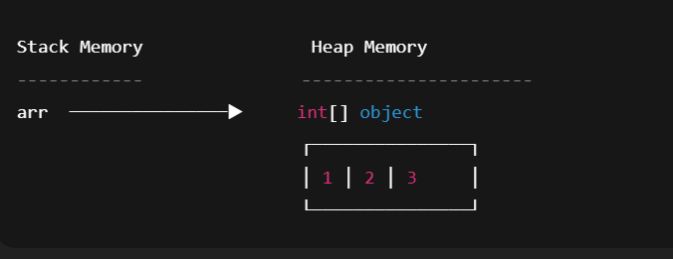

🔹 Why array is treated as an object in Java?
Because every array:
✔️ Is created using new (explicitly or implicitly)
✔️ Lives in heap memory
✔️ Has a class
✔️ Inherits from java.lang.Object
✔️ Has properties like length
Example:
System.out.println(arr.length); // property
System.out.println(arr.getClass()); // class info

🔹 What class is this array object?
For:
int[] arr = {1,2,3};
The runtime class is:
[I
Meaning:
- [ → array
- I → int
Similarly:
Array | Runtime Class
int[] | [I
double[] | [D
int[][] | [[I
👉 instanceof checks whether the object (in heap) belongs to a particular class or interface hierarchy.
So when you say:
arr instanceof Object
It means:
“Is the array object a part of the Object class hierarchy?”
✅ Yes → because every array in Java implicitly extends java.lang.Object.

✅ Correct Rule: What types are allowed as array size?
👉 Array size must be an integer type.
Java allows these types for array size:
✔️ byte
✔️ short
✔️ char
✔️ int
❌ Not allowed:
- long
- float
- double
- boolean

✅ Correct Example: Using byte as array size
byte b = 10;
int[] arr = new int[b];
✔️ Valid
📌 Reason:
- byte is implicitly widened to int
- JVM internally treats array size as int

✅ Using char as array size (IMPORTANT)
int[] arr = new int['a'];
✔️ Valid
📌 Explanation:
- 'a' is a char
- ASCII (Unicode) value of 'a' = 97
- char → int is implicit widening
- So JVM creates:
int[] arr = new int[97];

❌ Mistake Correction in Your Statement

❌ Incorrect wording
"we can store char in int which is implicit type casting but to store int in char explicit type casting is needed"

✅ Corrected & Precise Statement
- char → int → implicit widening conversion ✅
- int → char → explicit narrowing conversion ❌ (needs cast)

✅ Correct Type Conversion Table (Remember This)
Conversion | Allowed | Reason
byte → int | ✅ | widening
short → int | ✅ | widening
char → int | ✅ | widening
int → char | ❌ | narrowing
long → int | ❌ | possible data loss

❌ Invalid Examples (Very Important)
long l = 10;
int[] arr = new int[l]; // ❌ Compile-time error
float f = 5.5f;
int[] arr = new int[f]; // ❌ Compile-time error
📌 Reason:
- Array size must be implicitly convertible to int
- long, float, double are not allowed

🚨 Exceptions Related to Arrays in Java

1️⃣ ArrayIndexOutOfBoundsException
This exception occurs at runtime when an attempt is made to access an array index that is outside the valid range.
int[] arr = new int[2];
arr[2] = 10; // valid indexes are 0 and 1
📌 Reason:
The index 2 is greater than the highest valid index (1).

2️⃣ NegativeArraySizeException
This exception occurs at runtime when an array is created with a negative size.
int[] arr = new int[-2];
📌 Reason:
Array size must be zero or positive.
The JVM checks the size only at runtime.

3️⃣ ArrayStoreException
This exception occurs at runtime when an attempt is made to store an incompatible object type into an array of objects.
Object[] arr = new Integer[2];
arr[0] = "Hello"; // incompatible type
📌 Reason:
The array’s actual runtime type is Integer[], but a String object is being stored.
⚠️ Note:
ArrayStoreException applies only to object arrays, not to primitive arrays.

4️⃣ OutOfMemoryError
This error occurs at runtime when the JVM cannot allocate enough heap memory to create an array.
int[] arr = new int[Integer.MAX_VALUE];
📌 Reason:
The required memory exceeds the available heap space.

Eg: Array_Class

🧠 Core Concepts of Arrays (Very Simple + Snippets)

1️⃣ Every array in Java is an object
Even if it stores primitive values, the array itself is an object.
int[] arr = new int[3];
📌 Here, new int[3] creates an object in heap.

2️⃣ Array variable is only a reference
The variable does not store values.
It only stores the address of the array object.
int[] arr = {1, 2, 3};
📌 arr → reference
📌 {1,2,3} → object in heap

3️⃣ Primitive arrays are also objects
Even arrays of int, byte, char, etc., are objects.
byte[] b = new byte[2];
char[] c = new char[2];
📌 Values are primitive
📌 Container (array) is an object

4️⃣ JVM creates a special class for every array
Array classes are not written by programmers.
They are created by the JVM.
System.out.println(arr.getClass());

5️⃣ getClass().getName() shows internal JVM name
The name tells dimension + data type.
int[] a = new int[3];
System.out.println(a.getClass().getName());
Output:
[I

6️⃣ Number of [ tells the dimension
int[] a = new int[3]; // [I → 1D
int[][] b = new int[2][3]; // [[I → 2D
int[][][] c = new int[2][2][2]; // [[[I → 3D
📌 More [ → higher dimension

7️⃣ Letter after [ tells the data type
int[] a = new int[3]; // I → int
char[] b = new char[3]; // C → char
boolean[] c = new boolean[3]; // Z → boolean
📌 JVM uses short codes for primitive types
Array is an object in Java.
Every object has a class.
Using getClass().getName() gives the class name.
So [I is the class name.
✔️ This is absolutely right.

🔹 Why [I is a class name
int[] arr = {1, 2, 3};
System.out.println(arr.getClass().getName());
Output:
[I
📌 Meaning:
- JVM has created a real class
- The name of that class is [I
- This class represents one-dimensional int array
So yes:
👉 [I is the actual runtime class name of int[].

🔹 Important clarification (small but useful)
[I is:
- ✔️ A valid JVM internal class name
- ❌ Not a Java source-level class name (you cannot write class [I {})
It exists inside JVM, not in Java source code.

🔹 Proof that [I is a class
Class<?> c = arr.getClass();
System.out.println(c);
Output:
class [I
And:
System.out.println(c.getSuperclass());
Output:
class java.lang.Object
📌 This proves:
- [I is a class
- It extends Object

🔹 One-line final confirmation
👉 Yes, [I is the JVM-generated class name of an int[] object, returned by getClass().getName().

Eg: Array_Sum_Of_Elements
// go through the code

Eg: Array_Max_Element
// go through the code.

Eg: Array_Min_Element
//go through the code

Eg: Copy_1_Array_To_Another
// go through the code

Eg: Array_Eg1

🧠 Dry Run (Most Important Part)
Initial array:
Index: 0 1 2 3 4
Value: {0, 2, 4, 1, 3}

Iteration 1 → i = 0
arr[0] = 0
(0 + 3) / 5 = 3 / 5 = 0
arr[0] = arr[0] → 0

Iteration 2 → i = 1
arr[1] = 2
(2 + 3) / 5 = 5 / 5 = 1
arr[1] = arr[1] → 2

Iteration 3 → i = 2
arr[2] = 4
(4 + 3) / 5 = 7 / 5 = 1
arr[2] = arr[1] → 2

Iteration 4 → i = 3
arr[3] = 1
(1 + 3) / 5 = 4 / 5 = 0
arr[3] = arr[0] → 0

Iteration 5 → i = 4
arr[4] = 3
(3 + 3) / 5 = 6 / 5 = 1
arr[4] = arr[1] → 2

✅ Final Array After Loop
{0, 2, 2, 0, 2}

🖨️ Output
2

Eg : Array_Eg2

🧠 DRY RUN (VERY CLEAR & EXAM STYLE)

Initial Array State
Index : 0 1 2 3 4
Value : {1, 2, 3, 4, 5}

▶ Iteration 1
i = 0
i < 5 → true

a[i] = a[0] = 1
Printed → 1

i = i + 2 → i = 2

▶ Iteration 2
i = 2
i < 5 → true

a[i] = a[2] = 3
Printed → 3

i = i + 2 → i = 4

▶ Iteration 3
i = 4
i < 5 → true

a[i] = a[4] = 5
Printed → 5

i = i + 2 → i = 6

▶ Iteration 4
i = 6
i < 5 → false
Loop stops

✅ Final Output
1 3 5

Eg: Array_Eg3
// go through the code

Eg: Array_Eg4
//go through the code

Eg: Array_Eg5
int[][] n = {{1, 3}, {2, 4}};
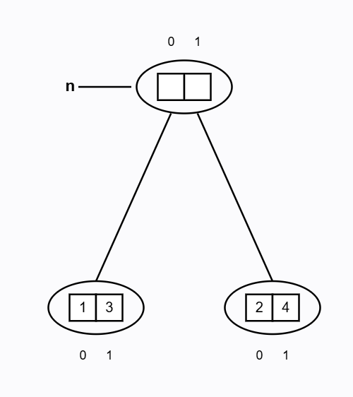

🧠 DRY RUN (WITH INTERNAL CONDITIONS — EXAM PERFECT)

Initial Setup
n.length = 2
So:
i = n.length - 1
i = 2 - 1 = 1

▶ OUTER LOOP – 1st ITERATION
i = 1
Check: i >= 0 → 1 >= 0 → true
So loop body executes.

Inner for-each loop
for (int y : n[1])
Row accessed:
n[1] → {2, 4}
for-each traversal (always LEFT → RIGHT):
y = 2 → print 2
y = 4 → print 4
Output so far:
2 4
Now:
i-- → i = 0

▶ OUTER LOOP – 2nd ITERATION
i = 0
Check: i >= 0 → 0 >= 0 → true
So loop body executes again.

Inner for-each loop
for (int y : n[0])
Row accessed:
n[0] → {1, 3}
for-each traversal:
y = 1 → print 1
y = 3 → print 3
Output so far:
2 4 1 3
Now:
i-- → i = -1

▶ OUTER LOOP – 3rd CHECK (STOP CONDITION)
i = -1
Check: i >= 0 → -1 >= 0 → false
Loop terminates.

✅ FINAL OUTPUT
2 4 1 3

Eg: Array_Eg6
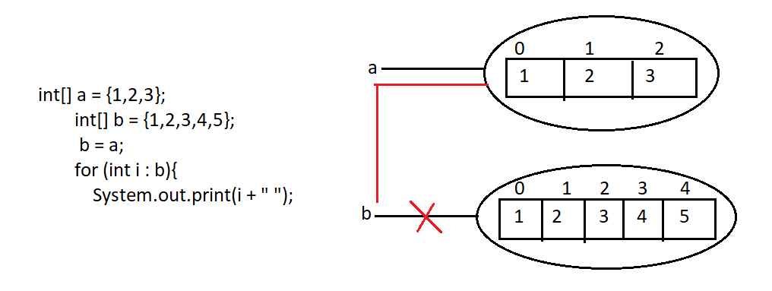
If b has more elements than a,
what happens if we write:
a = b;
Will Java give an error or not?

✅ SHORT ANSWER (INTERVIEW READY)
👉 NO error at all.
Java checks only the array TYPE, not the length.

🔁 Example Code
int[] a = {9, 8, 7}; // length = 3
int[] b = {1, 2, 3, 4, 5}; // length = 5

a = b; // perfectly valid

🧠 WHY NO ERROR? (CORE RULE)

🔑 Java Array Assignment Rule
During array assignment, compiler checks only the type (int[]),
length is checked at runtime only when accessing elements, not during assignment.
Both variables are:
int[] → SAME TYPE
So:
a = b; ✅ allowed

🧠 DRY RUN (MEMORY LEVEL)

▶ Before Assignment
Stack:
a → Array A (size 3)
b → Array B (size 5)
Heap:
Array A → {9, 8, 7}
Array B → {1, 2, 3, 4, 5}

▶ After Assignment
a = b;
Stack:
a → Array B
b → Array B
Heap:
Array B → {1, 2, 3, 4, 5}
👉 Old {9,8,7} array becomes eligible for GC
👉 No copying happens
👉 Only reference changes

⚠️ WHEN ERROR WILL COME? (VERY IMPORTANT)

❌ Runtime Error Case
a = b;
System.out.println(a[4]); // valid
System.out.println(a[5]); // ❌ ArrayIndexOutOfBoundsException
Because:
Array size = 5
Valid indexes = 0 to 4

❌ Compile-Time Error Case (TYPE MISMATCH)
int[] a;
double[] b;

a = b; // ❌ Compile-time error
Different types → not allowed

🏆 FINAL INTERVIEW GOLD LINE
👉 Array assignment in Java is based on type compatibility, not array length; length matters only during element access.

Eg: Array_Eg7
//go through the program

Eg: Array_Eg8
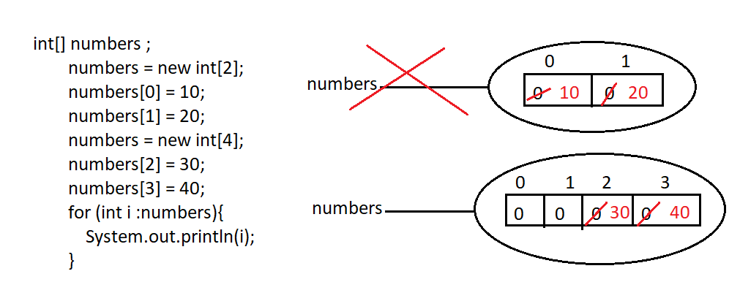
go through the code.

Eg: Array_Eg9
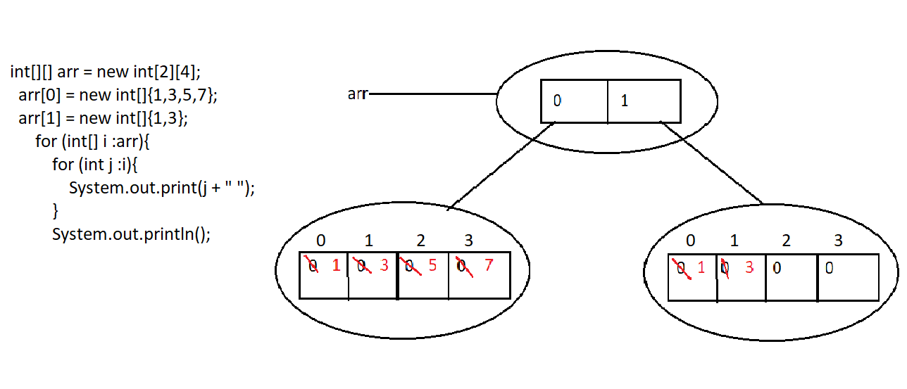

Eg: Array_Eg10
it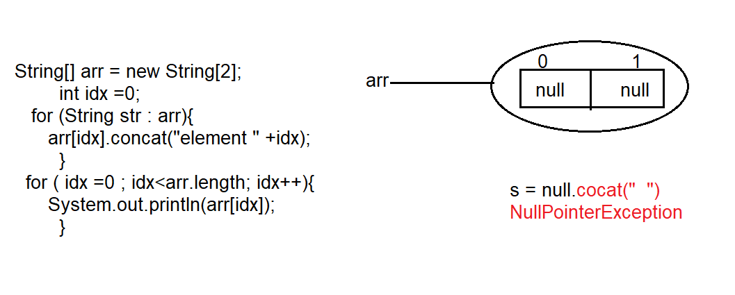
There is no element in the array and we are trying to use concat() method on it . it leads to NullPointerException.

If there are elements at location 0 and 1 then

🔁 Code we are talking about
String[] arr = {"hello", "pavan"};
int idx = 0;

for (String str : arr) {
arr[idx].concat("element " + idx);
}

▶ ITERATION 1 (WITH GC POINT)

Step 1: for-each picks first element
str = arr[0] = "hello"

Step 2: idx value
idx = 0

Step 3: Execute tricky line
arr[idx].concat("element " + idx)
→ arr[0].concat("element 0")
→ "hello".concat("element 0")
→ creates NEW String "helloelement 0"

Step 4: Return value
"helloelement 0" (returned)
❌ Not stored in any variable
❌ Not assigned back to the array
👉 Therefore:
"helloelement 0" → eligible for Garbage Collection
End of iteration 1:
Array = {"hello", "pavan"}
idx = 0

▶ ITERATION 2 (WITH GC POINT)

Step 1: for-each picks next element
str = arr[1] = "pavan"

Step 2: idx value
idx = 0 // unchanged

Step 3: Execute tricky line again
arr[idx].concat("element " + idx)
→ arr[0].concat("element 0")
→ "hello".concat("element 0")
→ creates NEW String "helloelement 0"

Step 4: Return value
"helloelement 0" (returned)
❌ Again not stored
❌ Again not referenced
👉 Therefore:
"helloelement 0" → eligible for Garbage Collection
End of iteration 2:
Array = {"hello", "pavan"}

▶ ITERATION 3
No
for-each ends because all elements are processed.

🧠 FINAL STATE
arr[0] = "hello"
arr[1] = "pavan"

🏆 FINAL GOLD LINE (PERFECT JVM LANGUAGE)
👉 Each call to concat() creates a new String object, and since the returned object is not referenced, it becomes eligible for garbage collection.

Eg: Array_Eg11
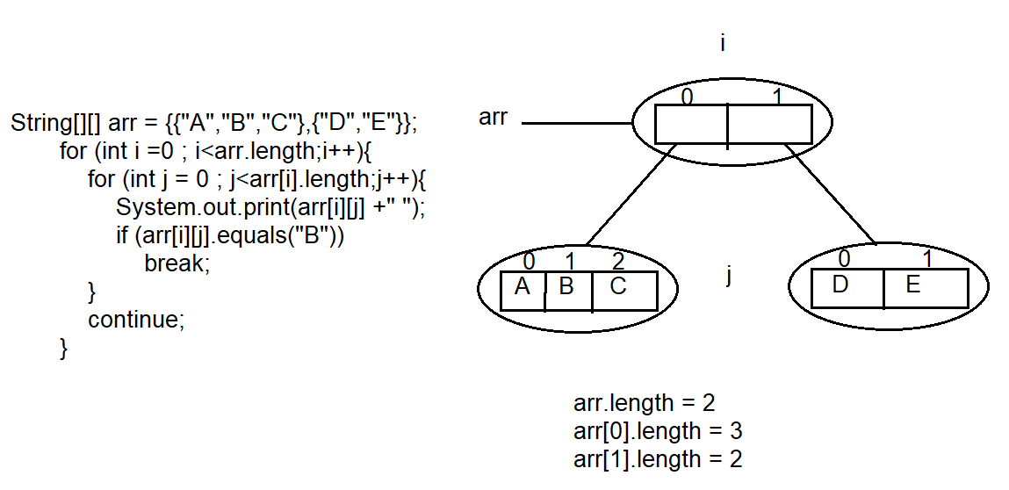

🔁 Code we are talking about
String[][] arr = {{"A","B","C"},{"C","D"}};

for (int i = 0; i < arr.length; i++) {
for (int j = 0; j < arr[i].length; j++) {
System.out.print(arr[i][j] + " ");
if (arr[i][j].equals("B"))
break;
}
continue;
}

▶ OUTER LOOP — ITERATION 1

Step 1: Outer loop starts
i = 0
Current row:
arr[0] = {"A", "B", "C"}

▶ INNER LOOP (Row 0)

▶ INNER ITERATION 1
Step 1: j value
j = 0
Step 2: Pick element
arr[0][0] = "A"
Step 3: Print
Output → A
Step 4: Check condition
"A".equals("B") → false
➡ No break
➡ Continue inner loop

▶ INNER ITERATION 2
Step 1: j value
j = 1
Step 2: Pick element
arr[0][1] = "B"
Step 3: Print
Output → B
Step 4: Check condition
"B".equals("B") → true
➡ break executes
➡ Inner loop stops immediately

End of INNER LOOP (Row 0)

Step 5: continue in outer loop
continue;
➡ Skips remaining outer-loop code
➡ Moves to next outer iteration (i++)

▶ OUTER LOOP — ITERATION 2

Step 1: Outer loop continues
i = 1
Current row:
arr[1] = {"C", "D"}

▶ INNER LOOP (Row 1)

▶ INNER ITERATION 1
Step 1: j value
j = 0
Step 2: Pick element
arr[1][0] = "C"
Step 3: Print
Output → C
Step 4: Check condition
"C".equals("B") → false
➡ Continue inner loop

▶ INNER ITERATION 2
Step 1: j value
j = 1
Step 2: Pick element
arr[1][1] = "D"
Step 3: Print
Output → D
Step 4: Check condition
"D".equals("B") → false
➡ Inner loop ends normally

End of INNER LOOP (Row 1)

Step 5: continue in outer loop
continue;
➡ Moves to next i

▶ OUTER LOOP — ITERATION 3
❌ No iteration
i = 2 → i < arr.length (2) → false
Outer loop ends.

🧠 FINAL OUTPUT
A B C D

❌ NO — continue should NOT always be the last statement
But…

✅ WHEN continue is written,
it must be the last statement that actually runs in that iteration.

🧠 Golden Rule (Very Important)
Once continue executes,
nothing after it in the same loop iteration will run.
So:
- Code can exist after continue
- But that code is unreachable in that iteration

✅ Common & CORRECT usage (continue in middle)
for (int i = 1; i <= 5; i++) {

if (i == 3) {
continue; // skip this iteration
}

System.out.println(i);
}

Execution:
i=1 → print
i=2 → print
i=3 → continue → skip println
i=4 → print
i=5 → print
Output:
1
2
4
5
✔️ Here continue is NOT the last line
✔️ But it acts as the last executed line for that iteration

❌ Useless usage (your previous code)
for (...) {
...
continue;
}
✔️ Valid syntax
❌ No logical use
❌ Same behavior without it

🚨 Compile-time Rule (Important)
This is ILLEGAL ❌
for (...) {
continue;
System.out.println("hello"); // unreachable code
}
👉 Java compiler error:
Unreachable code

🧠 Final Clear Answer
Question | Answer
Should continue be last line? | ❌ Not required
Does code run after continue? | ❌ Never
Is continue at end useful? | ❌ No
Best place for continue? | ✅ Before code you want to skip

🏁 One-line rule to remember
continue ends the current iteration immediately, wherever it appears.

Eg: Array_Eg12
// go through the program.

📌 Given Statements
1) int[] a = new int[];

2) int[][] a = new int[3][4];

3) int[][] a = new int[3][];

4) int[][] a = new int[][4];

5) int[][][] a = new int[3][4][5];

6) int[][][] a = new int[3][4][];

7) int[][][] a = new int[3][][5];

✅ VERY IMPORTANT RULE (Core Rule)
Base index (first dimension) MUST be given
Remaining indexes MAY or MAY NOT be given
📌 Base index = leftmost size

❌ INVALID CASES (1, 4, 7)

❌ 1) int[] a = new int[];
int[] a = new int[]; // ❌ INVALID
Why?
- This is a 1D array
- Base index is missing
- Compiler does NOT know how much memory to allocate
✔ Correct forms:
int[] a = new int[5];
int[] a = {1, 2, 3};

❌ 4) int[][] a = new int[][4];
int[][] a = new int[][4]; // ❌ INVALID
Why?
- Base index (first dimension) is missing
- Second dimension is given
- Java does NOT allow skipping the base index
👉 This violates the rule:
Base index must be specified

❌ 7) int[][][] a = new int[3][][5];
int[][][] a = new int[3][][5]; // ❌ INVALID
Why?
- First index is given ✔
- Second index is missing ❌
- Third index is given ❌
📌 You cannot give an index after skipping one

✅ VALID CASES (2, 3, 5, 6)

✅ 2) int[][] a = new int[3][4];
✔ Base index given
✔ All remaining indexes given

✅ 3) int[][] a = new int[3][];
✔ Base index given
✔ Remaining index optional

✅ 5) int[][][] a = new int[3][4][5];
✔ All dimensions given

✅ 6) int[][][] a = new int[3][4][];
✔ Base index given
✔ Middle index given
✔ Last index optional

📊 SUMMARY TABLE
Statement | Valid / Invalid | Reason
1 | ❌ Invalid | Base index missing
2 | ✅ Valid | All indexes given
3 | ✅ Valid | Base index given
4 | ❌ Invalid | Base index missing
5 | ✅ Valid | All indexes given
6 | ✅ Valid | Base + middle given
7 | ❌ Invalid | Index after missing one

🏁 ONE-LINE FINAL RULE (EXAM READY)
In Java arrays, you must give the base index; after that, indexes must be continuous—no skipping in between.

Eg: Array_Eg13
// go through the program

Eg: Array_Eg14
// go through the code

